Course Code: CL118

Credit Hour: 1

Program Section: SE(A)19

Programming Fundamentals LAB

Lab Instructors: Nida Munawar & Romasha Khurshid

# What Problem Can Be Solved by Computer

# When the solution can be produced by a set of step-by-step procedures or actions.

# This step-by-step action is called an algorithm.

# The algorithm will process some inputs and produced output.

# Solving problem by computer undergo two phases:

# Phase 1:

# Organizing the problem or pre-programming phase.

# Phase 2:

# Programming phase.

# PRE-PROGRAMMING PHASE

# This phase requires five steps:

# Analyzing the problem.

# Developing the Hierarchy Input Process Output (HIPO) chart or Interactivity Chart (IC).

# Developing the Input-Process-Output (IPO) Chart.

# Drawing the Program flowcharts.

# Writing the algorithms

# Analyzing The Problem

# Understand and analyze the problem to determine whether it can be solved by a computer.

# Analyze the requirements of the problem.

# Identify the following:

# Data requirement.

# Processing requirement or procedures that will be needed to solve the problem.

# The output.

# All These requirements can be presented in a Problem Analysis Chart (PAC)

|  |  |  |
| --- | --- | --- |
| Data | Processing | Output |
| Given in the problem or provided by the user. | List of processing required or procedures. | Output requirement. |

# Example # 01:

# Write a Problem Analysis Chart (PAC) to find an area of a circle where

# area = pi * radius * radius

|  |  |  |
| --- | --- | --- |
| Data | Processing | Output |
| radius | area = 3.14 x radius x radius | area |

# Developing the Hierarchy Input Process Output (HIPO) or Interactivity Chart

# The problem is normally big and complex.

# Thus, requires big program.

# Thus, the processing can be divided into subtasks called modules.

# Each module accomplishes one function.

# These modules are connected to each other to show the interaction of processing between the modules.

# Main/control module controls the flow all other modules.

# The IC is developed using top-down-method: top to down left to right order (also refer to order of processing).

# Modules are numbered, marked for duplication, repetition or decision.

# The interaction will form a hierarchy, called Hierarchy Input Process Output Chart (HIPO) or Interactivity Chart (IC). Programming which use this approach (problem is divided into subtasks) is called *Structured Programming*.

# 

# Example # 02:

# Write a Hierarchy Input Process Output (HIPO) to find an area of a circle where

# area = pi * radius * radius

# 

# Developing the Input Process Output (IPO) Chart

# Extends and organizes the information in the Problem Analysis Chart.

# It shows in more detail what data items are inputs, what is the processing or modules on that data, and what will be the result or output.

# It combines information from PAC and HIPO Chart.

# Example # 03:

# Write a Input Process Output (IPO) to find an area of a circle where

# area = pi * radius * radius

|  |  |  |  |
| --- | --- | --- | --- |
| Data | Processing | Module | Output |
| - radius | - Enter radius- area = 3.14 x radius x radius- Display area- end | 1000200030000000 | - Area of a circle |

# Drawing the Program Flowcharts

# Flowchart is the graphic representations of the individual steps or actions to implement a particular module.

# The flowchart can be likened to the blueprint of a building. An architect draws a blueprint before beginning construction on a building, so the programmer draws a flowchart before writing a program.

# Flowchart is independent of any programming language.

# Flowchart is the logical design of a program.

# It is the basis from which the actual program code is developed.

# Flowchart serves as documentation for computer program.

# The flowchart must be drawn according to definite rules and utilizes standard symbols adopted internationally.

# The International Organization for Standardization (IOS) was the symbols shown below (You can draw the symbols using ready-made flowcharting template):

**Flowchart** is a diagrammatic representation of sequence of logical steps of a program. Flowcharts use simple geometric shapes to depict processes and arrows to show relationships and process/data flow.

**Flowchart Symbols**

Here is a chart for some of the common symbols used in drawing flowcharts.

|  |  |  |
| --- | --- | --- |
| **Symbol** | **Symbol Name** | **Purpose** |
| Start Stop | Start/Stop | Used at the beginning and end of the algorithm to show start and end of the program. |
| Process | Process | Indicates processes like mathematical operations. |
| Input/ Output | Input/ Output | Used for denoting program inputs and outputs. |
| Decision | Decision | Stands for decision statements in a program, where answer is usually Yes or No. |
| Arrow | Arrow | Shows relationships between different shapes. |
| On-page Connector | On-page Connector | Connects two or more parts of a flowchart, which are on the same page. |
| Off-page Connector | Off-page Connector | Connects two parts of a flowchart which are spread over different pages. |

### **Guidelines for Developing Flowcharts**

These are some points to keep in mind while developing a flowchart −

* Flowchart can have only one start and one stop symbol
* On-page connectors are referenced using numbers
* Off-page connectors are referenced using alphabets
* General flow of processes is top to bottom or left to right
* Arrows should not cross each other

## **Example Flowcharts**

Here is the flowchart for going to the market to purchase a pen.

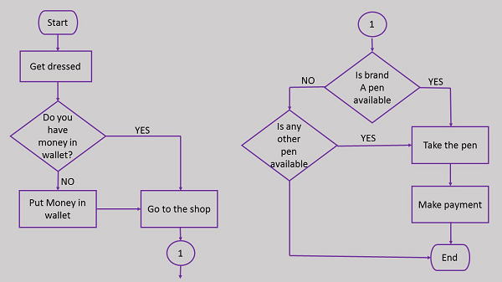

Draw a flowchart to calculate the average of two numbers.

**LAB TASK**

**Question # 01:** Write PAC, HIPO and IPO charts to find the percentage of a student? You can assume the Required data by your own.

**Question # 02:** Write a Problem Analysis Chart (PAC) to compute and display the temperature inside the earth in Celsius and Fahrenheit. The relevant formulas are Celsius = 10 x (depth) + 20Fahrenheit = 1.8 x (Celsius) + 32

**Question # 03** Write a HIPO to convert the distance in miles to kilometers where 1.609 kilometers per miles?

**Question # 04** The Pacific Gymnastic Meet at BC Place starts next week. The seating cost are: orange seats $23.50, brown seats $19.75, and yellow seats $16.55. There is a tax of 6% on all seats. Write an IPO Charts to find out the total selling cost?

**Question # 05** Read a sequence of number, find the average of the number and print the average. Solution: Stepwise Analysis of Average Problem

**Question # 06** Draw a flow chart to find a largest among two different numbers entered by user?